**General Philip Schuyler**

**1733 to 1804**

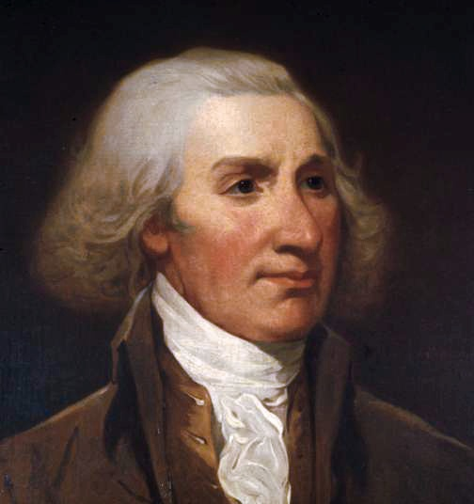

**Research Book “Freedom’s Gateway:**

**How the Empire State Created America**

**and Delivered upon the Promise of Liberty.”**

**Robert T. Farley**

Author